CREDIT CARD PROCESSING SYSTEM

USE CASE DIAGRAM

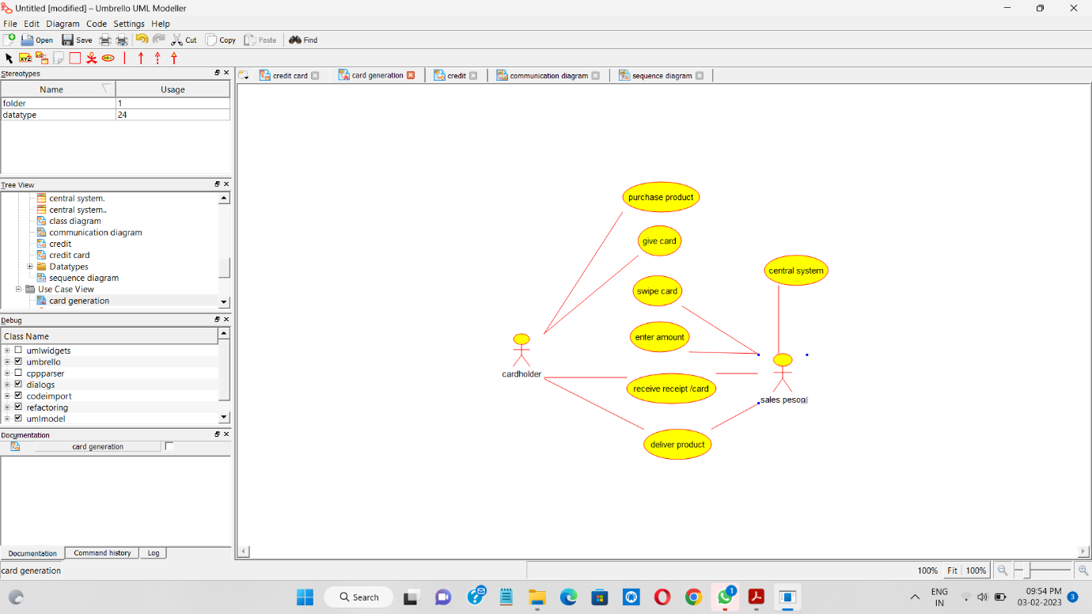

CLASS DIAGRAM

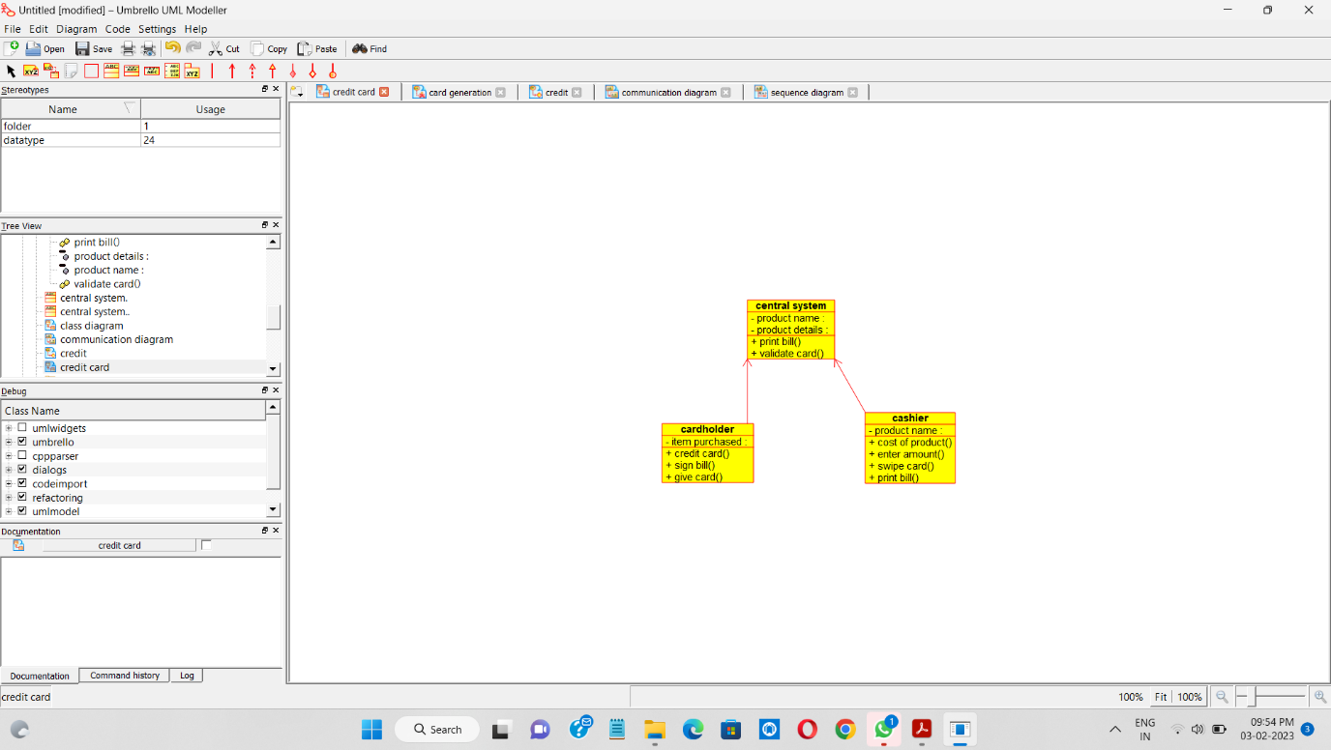

SEQUENCE DIAGRAM

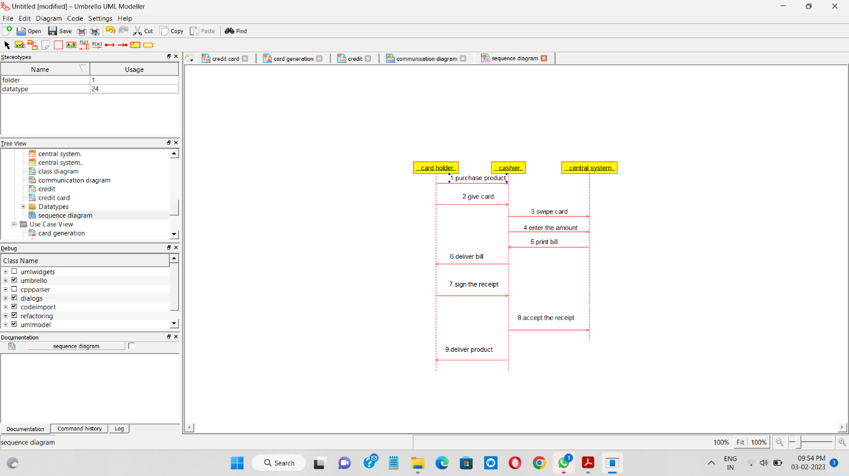

ACTIVITY DIAGRAM

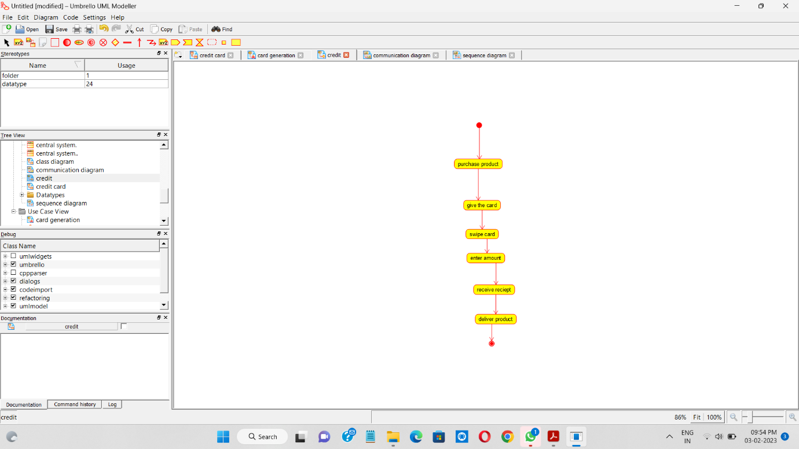

COLLABORATION DIAGRAM

